Design Document: American TV Show Community

1 Introduction to the overall system

The system aims to build a brand-new American drama fan community, provide American drama fans with high-quality American drama information, and create an online communication platform for American drama. Through this system, fans of American dramas can always receive the latest information about American dramas, bookmark American dramas they are interested in, and comment on American dramas. We also designed our exclusive LOGO, as shown in the picture below:



2 User needs analysis

(1) Understand the demand for high-quality American drama information

(2) Find the needs of related American dramas

(3) The need to mark favorite American dramas

(4) Demand for comments on American dramas

3 Functional module design

(1) Understand the demand for high-quality American drama information 🡪 American drama information

(2) Requirements for finding relevant American dramas 🡪 Search function

(3) The need to mark favorite American dramas 🡪 Favorite function

(4) Demand for commenting on American dramas 🡪 Comment function

In fact, user needs are also the reason for the design of each function. We did not conduct preliminary research or the like. Our functions are basically based on our own experience in browsing related websites such as Douban, Tencent Video, Mango TV, etc. For reference, we are fans of American dramas. What functions do we want or what functions can be achieved with our capabilities. Finally, the four basic functions of providing information, searching, collecting and commenting are determined.

4 Data Dictionary & Database Design

1. The design of the E-R diagram reflects our preliminary and complete idea of the database. Let’s first look at our E-R diagram (The E-R diagram cannot be found)

In the specific design, in order to reduce data redundancy, abnormal operations such as insertion and deletion, and to facilitate data input and search, we have modified the original idea. For example, in the user comment form, a user can add Multiple American dramas are commented, and one American drama can also have multiple commenting users, so we added ID as the main code to uniquely mark each comment. When searching and entering data in the early stage, for more convenience, we added two attributes of the Chinese and English names of American dramas in addition to the ID to the award table.

1. We have a total of 5 tables: American drama table, award table, user table, user comment information table and user collection information table. The following is a detailed explanation of the data dictionary:

Data structure see E-R diagram

Data item

American TV series (us_tv):

ID (master code INT)

TV_Premiere: premiere date (DATE)

TV_NAME_CH: Chinese name of American TV series (candidate code VARCHAR)

TV_NAME_EN: English name of American TV series (candidate code VARCHAR)

TV_TYPE: American drama type (VARCHAR)

TV_POSTER: poster address (VARCHAR)

TOMATOMETER: Professional scoring (FLOAT)

CRITIC_RATINGS: Number of Professional Ratings (INT)

AUDIENCE_SCORE: audience score (FLOAT)

USER_RATINGS: Number of audience ratings (INT)

TV_COMPANY: Production company (VARCHAR)

Awards table (awards):

ID (master code INT)

TV_NAME_CH: Chinese name of American TV series (candidate code VARCHAR)

TV_NAME_EN: English name of American TV series (candidate code VARCHAR)

EM_C_ACTOR: Emmy Award for Outstanding Lead Actor in a Comedy Series (VARCHAR)

EM_C_ACTRESS: Emmy Award for Outstanding Lead Actress in a Comedy Series (VARCHAR)

EM_C_MACTOR: Emmy Award for Outstanding Supporting Actor in a Comedy Series (VARCHAR)

EM_C_MACTRESS: Emmy Award for Outstanding Supporting Actress in a Comedy Series (VARCHAR)

EM_C_DIREC: Emmy Award for Outstanding Directing in a Comedy Series (VARCHAR)

EM_C_WRIT: Emmy Award for Outstanding Writing in a Comedy Series (VARCHAR)

EM_C: Emmy Award for Outstanding Comedy Series (VARCHAR)

EM_D_ACTOR: Emmy Award for Outstanding Lead Actor in a Drama Series (VARCHAR)

EM_D_ACTRESS: Emmy Award for Outstanding Lead Actress in a Drama Series (VARCHAR)

EM_D_MACTOR: Emmy Award for Outstanding Supporting Actor in a Drama Series (VARCHAR)

EM_D_MACTRESS: Emmy Award for Outstanding Supporting Actress in a Drama Series (VARCHAR)

EM_D_DIREC: Emmy Award for Outstanding Director in a Drama Series (VARCHAR)

EM_D_WRIT: Emmy Award for Outstanding Writing in a Drama Series (VARCHAR)

EM_D: Emmy Award for Outstanding Drama Series (VARCHAR)

EM_S_ACTOR: Emmy Award for Outstanding Lead Actor in a Limited Series/Movie (VARCHAR)

EM_S_ACTRESS: Emmy Award for Outstanding Lead Actress in a Limited Series/Movie (VARCHAR)

EM_S_MACTOR: Emmy Award for Outstanding Supporting Actor in a Limited Series or TV Movie (VARCHAR)

EM_S_MASTRESS: Emmy Award for Outstanding Supporting Actress in a Limited Series or TV Movie (VARCHAR)

EM_S_DIREC: Emmy Award for Directing a Limited Series or TV Movie (VARCHAR)

EM_S_WRIT: Emmy Award for Outstanding Writing for a Limited Series/Movie (VARCHAR)

EM_S: Emmy Award for Outstanding Limited Series/Movie (VARCHAR)

EM_A: Emmy Award for Best Animated Program (VARCHAR)

GGA_CM_ACTOR: Golden Globe Award for Best Actor in a Comedy Series (VARCHAR)

GGA_CM_ACTRESS: Golden Globe Award for Best Actress in a Comedy Series (VARCHAR)

GGA_CM_MACTOR: Golden Globe Award for Best Supporting Actor in a Comedy Series (VARCHAR)

GGA_CM_MASTRESS: Golden Globe Award for Best Supporting Actress in a Comedy Series (VARCHAR)

GGA_CM_DIREC: Golden Globe Award for Best Director in a Comedy (VARCHAR)

GGA_CM_WRIT: Golden Globe Award for Best Writing in a Comedy (VARCHAR)

GGA_CM: Golden Globes Best Comedy Series (VARCHAR)

GGA_D_ACTOR: Golden Globe Award for Best Actor in a Drama Series (VARCHAR)

GGA_D_ACTRESS: Golden Globe Award for Best Actress in a Drama Series (VARCHAR)

GGA_D_MACTOR: Golden Globe Award for Best Supporting Actor in a Drama Series (VARCHAR)

GGA_D_MACTRESS: Golden Globe Award for Best Supporting Actress in a Drama Series (VARCHAR)

GGA_D_DIREC: Golden Globe Award for Best Director in a Drama Series (VARCHAR)

GGA_D_WRIT: Golden Globe Award for Best Screenplay in a Drama Series (VARCHAR)

GGA_D: Golden Globe Award for Best Drama Series (VARCHAR)

GGA_S_ACTOR: Best Actor in a Limited Series/Movie at the Golden Globes (VARCHAR)

GGA_S_ACTRESS: Golden Globe Award for Best Actress in a Limited Series/Movie (VARCHAR)

GGA_S_MACTOR: Golden Globe Award for Best Supporting Actor in a Limited Series or TV Movie (VARCHAR)

GGA_S_MASTRESS: Best Supporting Actress in a Limited Series/Movie at the Golden Globes (VARCHAR)

GGA_S_DIREC: Golden Globe Award for Best Director of a Limited Series/TV Movie (VARCHAR)

GGA_S_WRIT: Best Writing for a Limited Series/Movie at the Golden Globes (VARCHAR)

GGA_S: Golden Globe Award for Best Limited Series/Movie (VARCHAR)

CCA_CM_ACTOR: Critics' Choice Award for Best Actor in a Comedy (VARCHAR)

CCA_CM_ACTRESS: Critics' Choice Award for Best Actress in a Comedy (VARCHAR)

CCA_CM_MACTOR: Critics' Choice Award for Best Supporting Actor in a Comedy (VARCHAR)

CCA_CM_MASTRESS: Critics' Choice Award for Best Supporting Actress in a Comedy (VARCHAR)

CCA_CM_DIREC: Critics' Choice Award for Best Director in a Comedy (VARCHAR)

CCA_CM_WRIT: Critics' Choice Award for Best Writing in a Comedy (VARCHAR)

CCA_CM: Critics' Choice Award for Best Comedy Series (VARCHAR)

CCA_D_ACTOR: Critics' Choice Award for Best Actor in a Drama Series (VARCHAR)

CCA_D_ACTRESS: Critics' Choice Award for Best Actress in a Drama Series (VARCHAR)

CCA_D_MACTOR: Critics' Choice Award for Best Supporting Actor in a Drama Series (VARCHAR)

CCA_D_MACTRESS: Critics' Choice Award for Best Supporting Actress in a Drama Series (VARCHAR)

CCA_D_DIREC: Critics' Choice Award for Best Director in a Drama Series (VARCHAR)

CCA_D_WRIT: Critics' Choice Award for Best Writing in a Drama Series (VARCHAR)

CCA_D: Critics' Choice Award for Best Drama Series (VARCHAR)

CCA_S_ACTOR: Critics' Choice Award for Best Actor in a Limited Series/Movie (VARCHAR)

CCA_S_ACTRESS: Critics' Choice Award for Best Actress in a Limited Series/Movie (VARCHAR)

CCA_S_MACTOR: Critics' Choice Award for Best Supporting Actor in a Limited Series/Movie (VARCHAR)

CCA_S_MASTRESS: Critics' Choice Award for Best Supporting Actress in a Limited Series/Movie (VARCHAR)

CCA_S_DIREC: Critics' Choice Award for Best Director of a Limited Series/TV Movie (VARCHAR)

CCA_S_WRIT: Critics' Choice Award for Best Writing for a Limited Series/Movie (VARCHAR)

CCA_S: Critics' Choice Award for Best Limited Series/TV Movie (VARCHAR)

CCA_A: Critics' Choice Awards Best Animation Festival (VARCHAR)

User table (user):

ID (master code INT)

ACCOUNT: user account (INT)

PASSWORD: user password (INT)

USER_NAME: username (VARCHAR)

User comment information table (user_details):

ID

USER_ACCOUNT: user account (INT)

USER_NAME: username (VARCHAR)

COMMENT: Comment content (VARCHAR)

COMMENTED_SERIES_ID: ID of the commented American TV series (external code INT)

User collection information table (user_collection):

ID (master code INT)

USER_ACCOUNT: user account (INT)

COLLECTED_SERIES_ID: ID of the collected American TV series (external code INT)

Data Flow

(1) User registration

Name: User Registration

Brief description: User information registration

Data source: users

Where the data goes: user table

Data composition: user ID + user account + user password + user name

(2) American drama information

Name: American Drama Information

Brief description: American drama information entry

Data source: administrator

Data destination: American drama table + award table

Data composition: ID + first broadcast time + Chinese name of American drama + English name of American drama + type of American drama + poster address + professional rating + number of professional rating + audience rating + number of audience rating + American TV award information

(3) comments

Name: Comment

Brief description: User comments on American dramas

Data source: users

Data destination: user comment information table

Data composition: user ID + user account + user name + comment content + commented American drama ID

(4) Favorites

Name: Favorites

Brief description: User's collection of American TV series

Data source: users

Data destination: user collection information table

Data composition: user ID + user account + ID of favorite American TV series

5 Function module introduction, with interface and core code attached

1. Provide information on American dramas (data obtained from Douban and Rotten Tomatoes)



It can be seen that we have selected three different arrangements to provide users with American drama information: the most recent update—arranged according to the latest premiere time; the hottest show—arranged by (number of professional judges + number of audience judges); Positive review—arrange according to the total score of (0.6*professional rating+0.4*popular rating).

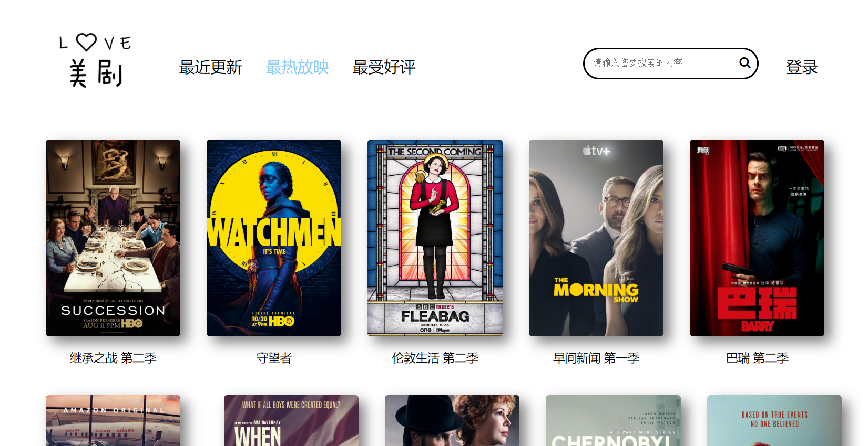

In addition, we also provide detailed information on American dramas: premiere time, ratings, production companies, awards, etc. You can enter the details page no matter you click on the poster picture or the name of the American drama.

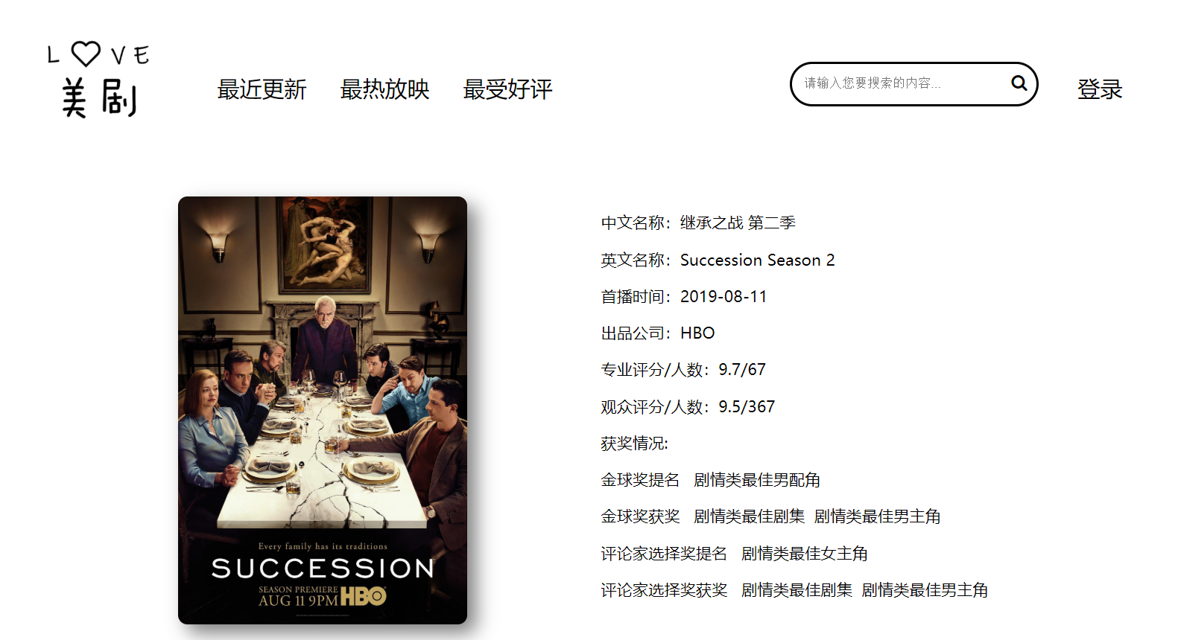

1. search

Search the Chinese name of the American TV series, and you can search for related American TV series.



1. Favorites

After the user logs in, on the details page of American dramas, users can collect American dramas.

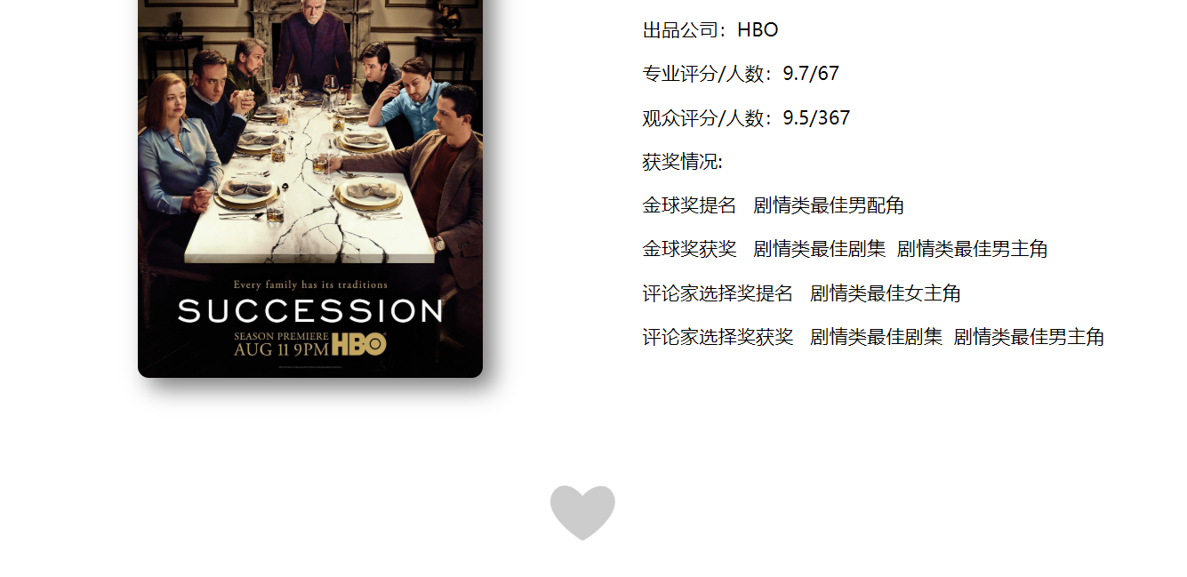

1. comments

After the user logs in, on the details page of the American TV series, the user can comment on the American TV series, and at the same time, the user can also see other comments on the American TV series.

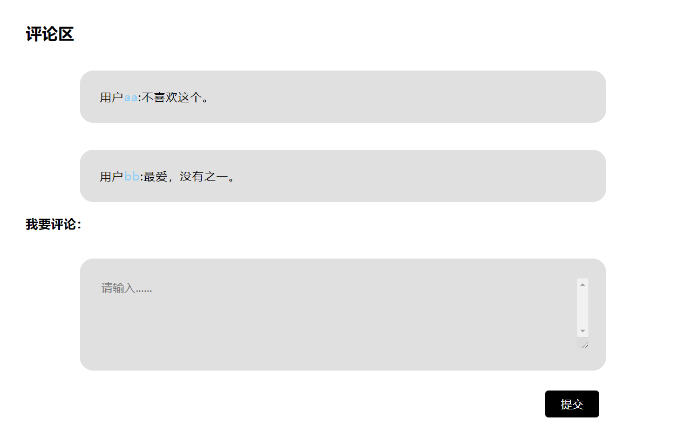

1. Login and registration

Users can log in and register on the page to bookmark and comment on American dramas they are interested in.



1. Personal center

After logging in, users can enter the personal center page to view their favorite American dramas and their own comments on American dramas.

